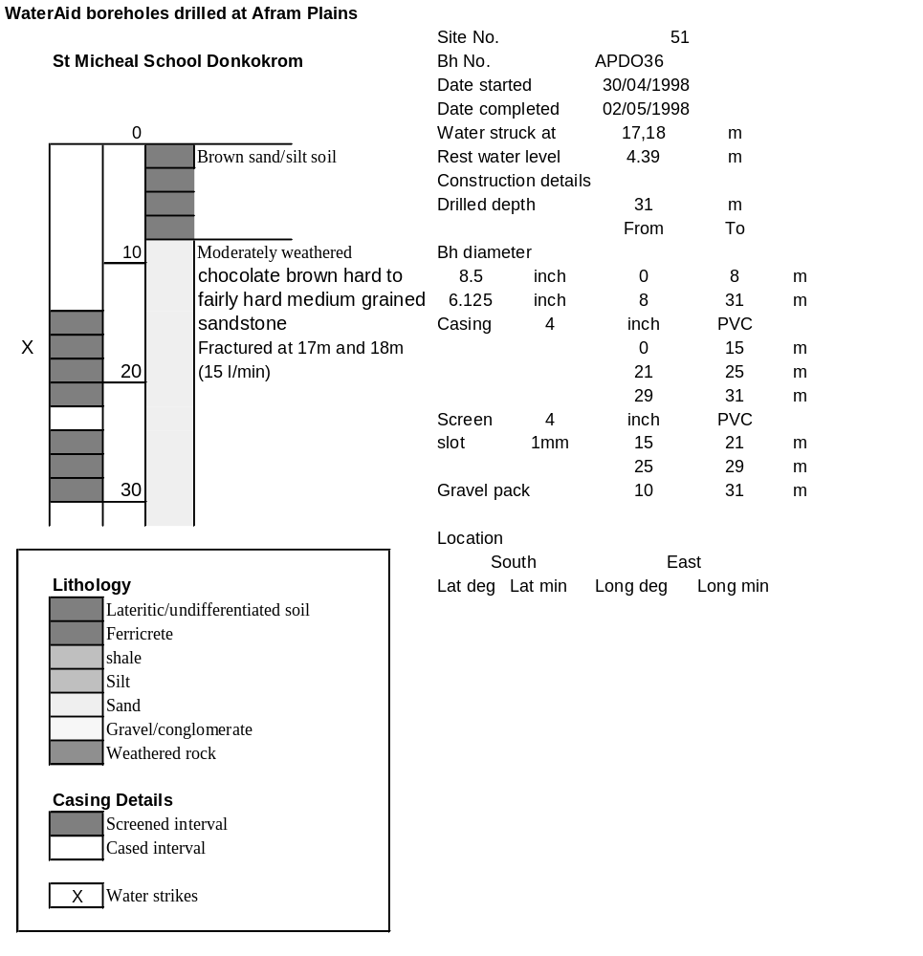

Ghana | Test pumping
Borehole No. |  | APDO36
Hole No |  | 51
Village |  | Donkorkrom
Date |  | 19/11/1998
Point above GL |  | 0.59 | m
Pump depth |  | 23 | m
SWL |  | 4.98 | m
Start Time |  | 08:21
Drawdown test |  |  |  |  | Recovery Test
time | pwl (m) | Q l/min | dd | sc(q/s) | Time | wl (m) | t/t' | resdd
0.00 | 4.98 | 15.00 | 0.00 |  | 0.00 | 14.17 |  | 9.19
1.00 | 7.59 | 15.00 | 2.61 | 5.75 | 1.00 | 13.44 | 241.00 | 8.46
2.00 | 8.18 | 15.00 | 3.20 | 4.69 | 2.00 | 12.93 | 121.00 | 7.95
3.00 | 8.59 | 15.00 | 3.61 | 4.16 | 3.00 | 12.50 | 81.00 | 7.52
4.00 | 8.94 | 15.00 | 3.96 | 3.79 | 4.00 | 12.11 | 61.00 | 7.13
5.00 | 9.20 | 15.00 | 4.22 | 3.55 | 5.00 | 11.77 | 49.00 | 6.79
6.00 | 9.43 | 15.00 | 4.45 | 3.37 | 6.00 | 11.41 | 41.00 | 6.43
7.00 | 9.64 | 15.00 | 4.66 | 3.22 | 7.00 | 11.09 | 35.29 | 6.11
8.00 | 9.83 | 15.00 | 4.85 | 3.09 | 8.00 | 10.79 | 31.00 | 5.81
9.00 | 9.97 | 15.00 | 4.99 | 3.01 | 9.00 | 10.51 | 27.67 | 5.53
10.00 | 10.12 | 15.00 | 5.14 | 2.92 | 10.00 | 10.28 | 25.00 | 5.30
12.00 | 10.29 | 15.00 | 5.31 | 2.82 | 12.00 | 9.85 | 21.00 | 4.87
14.00 | 10.44 | 15.00 | 5.46 | 2.75 | 14.00 | 9.48 | 18.14 | 4.50
16.00 | 10.57 | 14.00 | 5.59 | 2.50 | 16.00 | 9.14 | 16.00 | 4.16
18.00 | 10.93 | 15.00 | 5.95 | 2.52 | 18.00 | 8.85 | 14.33 | 3.87
20.00 | 11.32 | 15.00 | 6.34 | 2.37 | 20.00 | 8.60 | 13.00 | 3.62
25.00 | 11.96 | 15.00 | 6.98 | 2.15 | 25.00 | 8.11 | 10.60 | 3.13
30.00 | 12.40 | 15.00 | 7.42 | 2.02 | 30.00 | 7.73 | 9.00 | 2.75
35.00 | 12.77 | 15.00 | 7.79 | 1.93 | 35.00 | 7.39 | 7.86 | 2.41
40.00 | 13.10 | 15.00 | 8.12 | 1.85 | 40.00 | 7.14 | 7.00 | 2.16
45.00 | 13.39 | 15.00 | 8.41 | 1.78 | 45.00 | 6.96 | 6.33 | 1.98
50.00 | 13.64 | 15.00 | 8.66 | 1.73 | 50.00 | 6.81 | 5.80 | 1.83
55.00 | 13.89 | 15.00 | 8.91 | 1.68 | 55.00 | 6.69 | 5.36 | 1.71
60.00 | 14.12 | 15.00 | 9.14 | 1.64 | 60.00 | 6.58 | 5.00 | 1.60
70.00 | 14.06 | 12.00 | 9.08 | 1.32 | 70.00 | 6.40 | 4.43 | 1.42
80.00 | 14.12 | 12.00 | 9.14 | 1.31 | 80.00 | 6.26 | 4.00 | 1.28
90.00 | 13.93 | 12.00 | 8.95 | 1.34 | 90.00 | 6.14 | 3.67 | 1.16
100.00 | 13.88 | 12.00 | 8.90 | 1.35 | 100.00 | 6.02 | 3.40 | 1.04
110.00 | 13.86 | 12.00 | 8.88 | 1.35 | 110.00 | 5.91 | 3.18 | 0.93
120.00 | 13.87 | 12.00 | 8.89 | 1.35 | 120.00 | 5.85 | 3.00 | 0.87
130.00 | 13.86 | 12.00 | 8.88 | 1.35
140.00 | 13.86 | 12.00 | 8.88 | 1.35
150.00 | 13.88 | 12.00 | 8.90 | 1.35
160.00 | 13.91 | 12.00 | 8.93 | 1.34
170.00 | 13.93 | 12.00 | 8.95 | 1.34
180.00 | 13.97 | 12.00 | 8.99 | 1.33
190.00 | 14.00 | 12.00 | 9.02 | 1.33
200.00 | 14.04 | 12.00 | 9.06 | 1.32
210.00 | 14.08 | 12.00 | 9.10 | 1.32
220.00 | 14.11 | 12.00 | 9.13 | 1.31
230.00 | 14.15 | 12.00 | 9.17 | 1.31
240.00 | 14.17 | 12.00 | 9.19 | 1.31

